REPUBLIC OF THE PHILIPPINES
Department Of Education
Division of Valencia City
VALENCIA NATIONAL HIGH SCHOOL

GENOMOPRH
Transform and Thrive. Keep the Wild Alive.

GAME DEVELOPMENT PROPOSAL

PhsynTaK’s

Kent Dave R. Pilar
Pshych Earl B. Caleñada
Thomas Kyle L. Galo
Ace B. Cardeño

Valencia National Highschool
Valencia City, Bukidnon, Region X (Northern Mindanao), Philippines

May 25, 2026
Game Overview
The game is a fast-paced, ecological action-RPG where real-world science replaces traditional fantasy magic. The player controls a Nature Volunteer equipped with a prototype shape-shifting suit—The GenoMorph. Relying on advanced sensor feedback and live telemetry, the suit stores native animal DNA sequences to safely alter the user's physical form. By shifting into different native species (a frog, a bird, an aquatic animal, and a heavy mammal), the player navigates a dying, polluted region. Beyond combat and exploration, the core goal of the game is educational: players must actively learn and apply actual biology and environmental science to progress. By understanding and utilizing these real-world biological traits, the player repairs the broken food chain from the inside out, making scientific discovery the ultimate key to saving the ecosystem. Each animal form possesses a unique biology-based action skill, such as the Frog’s Cutaneous Respiration, the Hornbill’s Thermal Soaring, the Shark’s Lateral Line Sense, and the Tamaraw’s Ruminant Endurance, which are all inspired by real-world animal adaptations and survival behaviors. Furthermore, GenoMorph animal form is equipped with a biologically inspired action skill that integrates both offensive and defensive mechanics. These abilities are directly derived from real-world animal adaptations and are translated into combat systems that enhance survival, mobility, and ecosystem interaction within each biome.
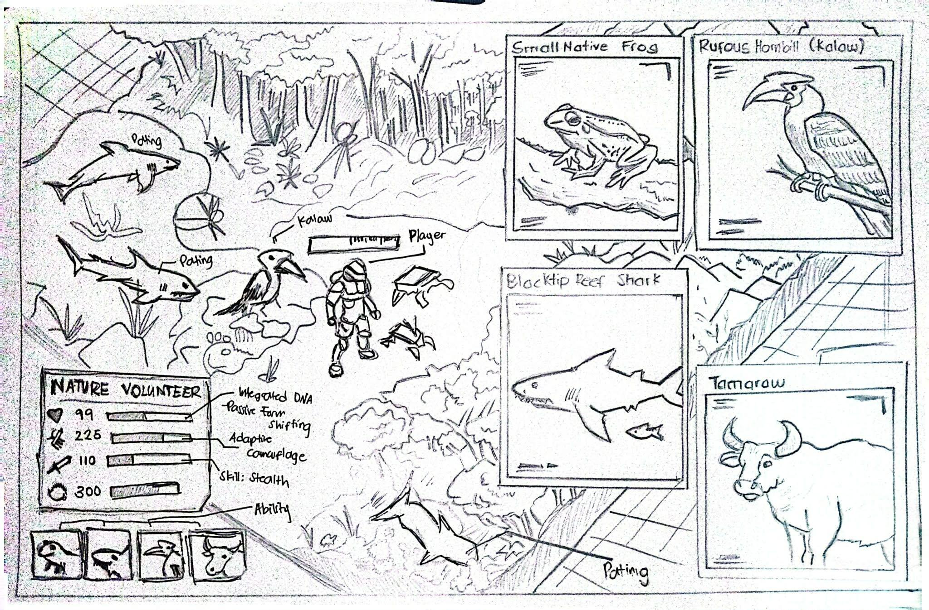

Figure 1. CONCEPT SKETCH

The figure 1 above demonstrates the core in-game perspective and user interface layout players will utilize during exploration and combat. The game employs a top-down isometric camera angle, providing a wide, clear view of the environment so players can anticipate incoming attacks, spot invasive pests, and plan dodges during chaotic boss fights. At the center of the action is the Nature Volunteer, whose high-tech prototype suit visually contrasts with the natural surroundings to emphasize the blend of advanced technology and ecological restoration. The detailed panels on the right represent the suit's DNA storage interface, which will be streamlined into quick-tap buttons in the final build to allow instant hot-swapping between the Small Native Frog, Rufous Hornbill, Blacktip Reef Shark, and Tamaraw forms mid-combat. Finally, the interface integrates essential survival data, displaying the player's health, stamina, and active form stats in the bottom left corner so critical information is always accessible at a glance.

- Concept and Storyline
Game Concept
The story is set in a once-vibrant natural region that is now on the verge of total environmental collapse due to severe human-induced pollution, habitat fragmentation, and the introduction of aggressive foreign pests. Desperate to study this damage without causing further harm to the fragile environment, Dr. Alistair Sterling, a scientist, invents a revolutionary technology: The GenoMorph. This high-tech suit is capable of storing native animal DNA sequences and safely altering the user's physical form. Because the toxic wilderness is too dangerous for the scientist to navigate himself, he recruits a brave Nature Volunteer (the Protagonist) to wear the suit. The scientist remains safely in his laboratory, observing the data and guiding the player remotely through the suit's built-in radio.
While they are conducting the very first initial test of the GenoMorph suit, a catastrophic system malfunction triggers a power surge that violently wipes the main database. All of the other animal DNA is scattered to the different biomes across the region and immediately absorbed by the local invasive pests and animals, mutating them into massive Invasive Chimeras, which are creatures whose single bodies are composed of a mix of distinct animal DNAs and forms . Because this DNA is now scattered, the player loses the ability to shapeshift into other animals. Stranded in a toxic swamp and locked into the entry-level form of a Small Native Frog, the Nature Volunteer must track down these corrupted beasts to defeat them and obtain the lost data.
Level Progression
Level 1: The Polluted Wetlands (Frog Form)
- Exploration & Action Sidequests: The player begins at the bottom of the food chain as a Small Native Frog in a stagnant swamp. While navigating the terrain, the player encounters "Invasive Nests." Instead of simply walking past, the player must use their real-time combat controls (basic attacks and dodges) to clear these nests. Clearing a nest instantly restores a localized patch of the wetland and grants temporary experience buffs. The player locates an elder frog NPC, who provides a localized history of the wetland’s decline .
- Combat-Integrated Minigame: To gain the elder frog's trust, the player enters a specialized arena for a biological control challenge. Swarms of invasive mosquitoes spawn from the edges of the screen. Instead of a simple tapping game, the player must utilize their frog's basic attacks and newly unlocked Area of Effect (AoE) skills to "consume" the swarms before they infect the center of the pond. This merges real-time wave-clearing with the scientific lesson of population dynamics.
- Combat and Skills: Sustained combat against smaller marsh pests like mosquitoes allows the player to unlock the Cutaneous Respiration action skill. The skill allows the frog to dash into scattered water puddles to rapidly regenerate health, teaching players how amphibians absorb moisture and oxygen directly through their skin.

- Boss Fight and Progression: The player enters a locked arena to face the mutated Snail-Toad Chimera, requiring active dodging of toxic sludge projectiles and heavy shell slams. Upon defeating the boss, the player extracts the corrupted leaping-muscle and obtain it. The suit purifies this sequence into the lost bird DNA, immediately unlocking the Avian Form to fly over a massive concrete highway blocking access to the next zone.
Level 2: The Fragmented Rainforest (Rufous Hornbill Form)
- Exploration & Action Sidequests: Transitioning into the Rufous Hornbill (Kalaw) Form, the player experiences a dramatic shift in verticality, controlling a heavy, powerful flyer. The environment is heavily fragmented by illegal logging roads. The player undertakes an active escort mission sidequest, utilizing the hornbill's heavy flight momentum to defend a vulnerable, smaller native bird from ambushing airborne pests as it crosses a hazardous logging camp.
- Combat-Integrated Minigame: The frugivory and seed dispersal lesson is converted into a high-speed, action-targeting sequence. Acting as the "farmer of the forest," the player flies over the canopy, simultaneously fighting off territorial invasive insects while precisely aiming and dropping large, restorative fruit seeds into fertile patches of dirt below. This directly applies action combat mechanics to real-world forest succession.
- Combat and Skills: Continuous aerial dogfights unlock the Thermal Soaring active skill, granting a vertical dash that utilizes warm updrafts. This provides temporary invincibility frames (i-frames), allowing the player to completely dodge sweeping ground-based attacks from enemies below. The hornbill form's primary basic attacks utilize its massive beak for heavy, localized damage.
- Boss Fight and Progression: The player drops into a cleared logging zone to confront the Feral Hog-Rodent Chimera. The player must utilize Thermal Soaring to avoid erratic charge attacks and rooting mechanics, while using the hornbill's heavy "Casque Dive" action skill to deliver severe blunt-force trauma to crack the chimera's armor. After a successful takedown, the player extracts the beast's dense hide, obtaining the lost aquatic DNA. The suit unlocks the Aquatic Form, which is required to dive into the deep, high-pressure river currents leading to the ocean.

Level 3: The Bleached Coral Reef (Blacktip Reef Shark Form)
- Exploration & Action Sidequests: The environment shifts to a fully underwater, 360-degree movement system in a pale reef devastated by ocean acidification. Operating as the highly agile Blacktip Reef Shark (Pating), the player engages in "Tower Defense" style resource gathering. When attempting to harvest a rare, medicinal coral to heal a surviving sea turtle NPC, the player utilizes the shark's high-speed burst attacks to hold their ground and survive a 60-second wave-based battle against aggressive scavenger fish to secure the extraction.
- Combat-Integrated Minigame: The visual mimicry lesson becomes a high-speed stealth and combat infiltration mission. The player must navigate a narrow trench heavily guarded by toxic Lionfish. They must use their tactical dashes to weave past deadly translucent plastic bags (which mimic jellyfish) while rapidly engaging or evading the invasive predators in real-time combat, simulating the high-stakes survival of native marine life.
- Combat and Skills: Battling underwater requires managing positioning and current drift. Perfectly suited for a shark, the player unlocks the Lateral Line Sense skill. This biological radar temporarily draws bright, visible telegraph lines on the UI, revealing the exact trajectories of incoming, otherwise invisible enemy attacks based on microscopic water displacement.
- Boss Fight and Progression: In the deepest part of the reef, the player faces the Lionfish-Starfish Chimera in a "bullet-hell" style encounter. The player must use the shark's rapid dash mechanics to weave through waves of venomous spine projectiles, rapidly close the distance to land a quick bite, and dart away before the starfish's regenerative feeding state triggers. Defeating the chimera secures the heavy mammal DNA, unlocking the massive Heavy Form to smash through the reinforced boulders blocking the mountain path.
Level 4: The Highland Mountains (Tamaraw Form)
- Exploration & Action Sidequests: Operating in the massive Tamaraw (Mindoro Dwarf Buffalo) Form, the player ascends the freezing, e-waste-polluted highland summit. The movement is heavy, deliberate, and incredibly durable. The player discovers a trapped mountain goat NPC pinned beneath reinforced boulders and heavily surrounded by the final, most dangerous tier of invasive pests. Utilizing the Tamaraw's sheer physical mass and V-shaped horns, the player must aggressively charge and clear the heavily fortified enemy camps to safely reach the NPC.
- Combat-Integrated Minigame: To clear the path and save the goat, the player must fend off continuous enemy attacks while charging a kinetic attack meter. They must perfectly time their combat skill inputs to stop a fast-moving slider inside a narrow "green zone," executing a maximum-force strike to shatter the boulders before the goat's health depletes.
- Boss Fight and Progression: At the absolute peak, the player initiates the final encounter against the Apex Chimera, a massive entity that constantly mutates through the abilities of all previous bosses. The player must master a dynamic hot-swapping combat system to survive. They must rapidly transition between the agile Frog, the evasive Rufous Hornbill, the high-speed Blacktip Reef Shark, and the heavy-hitting Tamaraw mid-combat to continuously counter the Apex’s shifting weaknesses and manage their varying skill cooldowns.
- Resolution: Upon landing the final blow and extracting the core DNA sequence, Dr. Sterling pushes a complete software patch to the suit. Operating at 100% capacity, the Nature Volunteer officially assumes the role of an apex Keystone Species. The food web mathematically stabilizes, triggering a massive phytoremediation and ecological restoration event that cleanses the water, regrows the canopy, and restores vibrant color to the entire map.
With the Chimeras defeated, Dr. Alistair Sterling is finally able to fully patch The GenoMorph. With a complete database, the Nature Volunteer steps into the environment as the ultimate Keystone Species. This final act perfectly balances the food web, triggering a massive, global Ecological Restoration that visually heals the entire region back to a lush, green paradise.

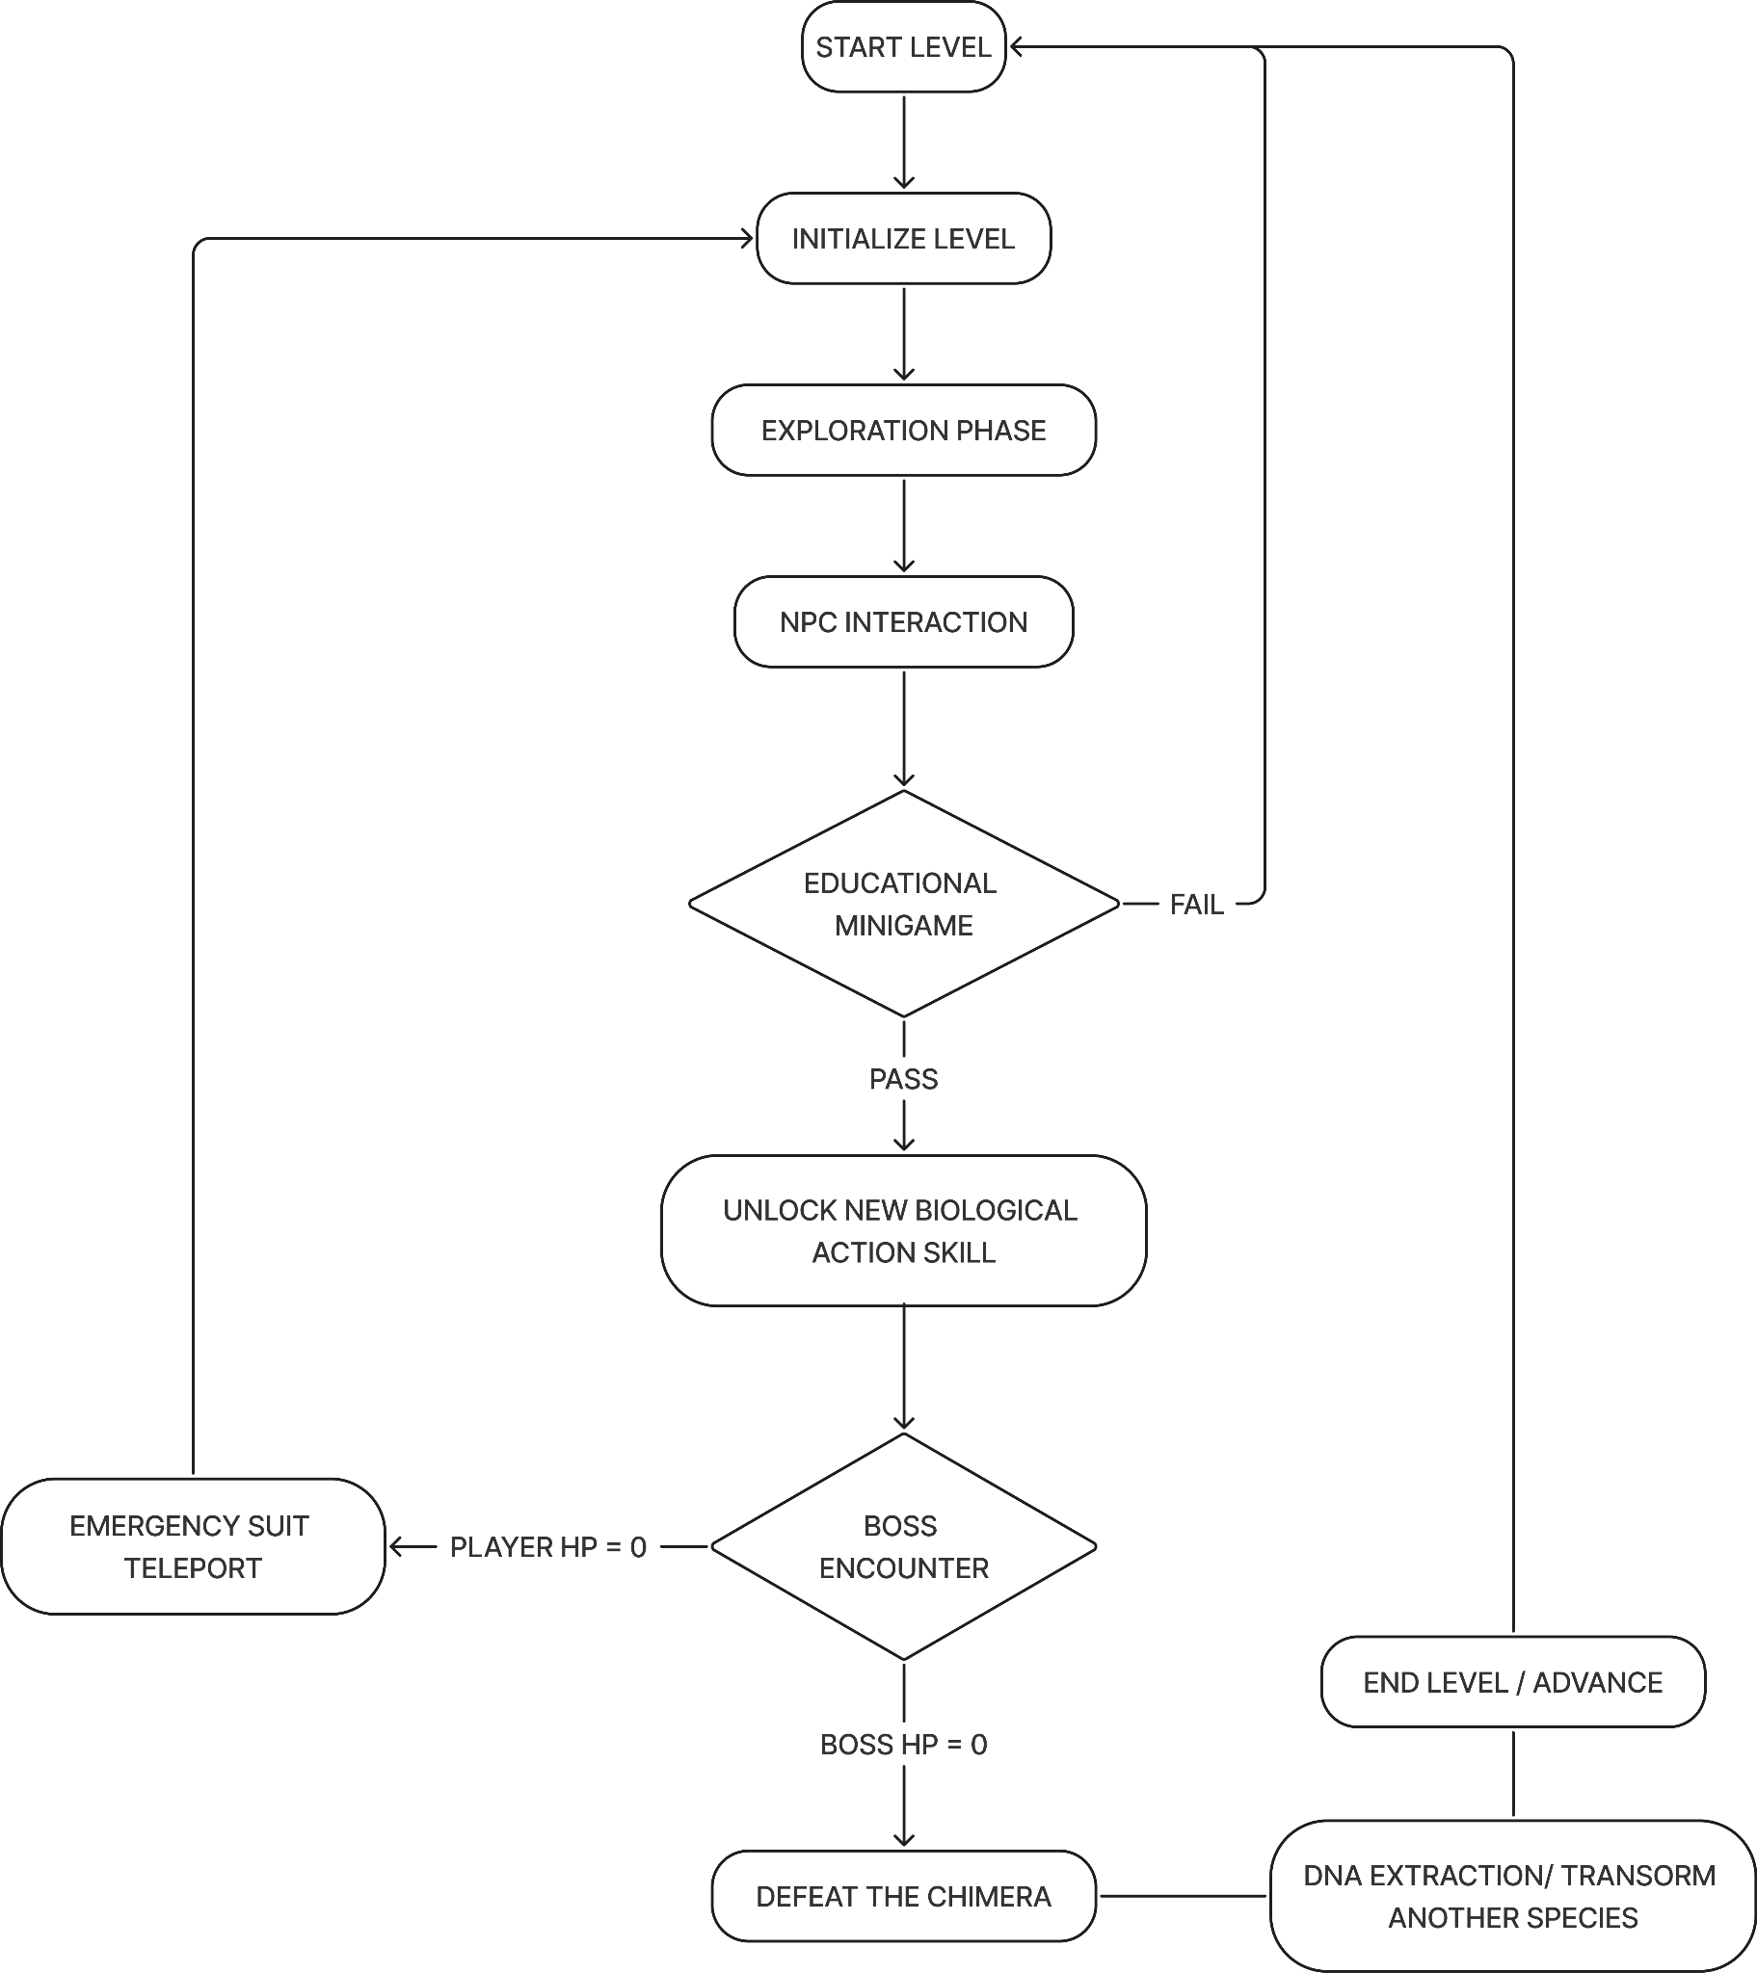
- Gameplay Design
Core Gameplay Loop

Figure 2. Core Gameplay Loop
The flowchart above illustrates the step-by-step logic of a standard level in the game. This loop is designed to seamlessly blend exploration, educational mechanics, and action combat. Here is a detailed breakdown of each phase the player experiences:
Phase 1: Initialization and Exploration
- Initialize Level: The sequence begins with the player spawning into the biome using their current base animal form (e.g., the Small Native Frog).
- Exploration Phase: The player navigates the map from a top-down perspective. They must use basic real-time combat to clear out "Invasive Nests," which slowly restores small patches of the polluted environment and opens up the path forward.

Phase 2: Education and Skill Acquisition
- NPC Interaction: The player locates a Native Guide (like the Elder Frog or the Mountain Goat). Interacting with this NPC provides crucial biome data, contextualizes the ecological problem, and unlocks the level's primary objective.
- Educational Minigame: The player must complete a science-grounded minigame (such as dropping seeds for forest succession).
  - Fail State: If the player fails, they are simply looped back to restart the minigame until they understand the concept.
  - Pass State: Successfully completing the minigame grants the player a new Biological Action Skill (like Thermal Soaring or Cutaneous Respiration), which is required for the upcoming boss fight.

- Biological Action Skills System: Each animal form has one biologically grounded skill with both attack and defense functions:
  - Frog — Cutaneous Burst Recovery (regeneration + close-range control)
  - Hornbill — Casque Impact Dive (aerial attack + mid-air evasion)
  - Shark — Lateral Line Predation System (attack prediction + precision strikes)
  - Tamaraw — Horned Bulwark Charge (damage resistance + momentum attack)

Phase 3: The Chimera Boss Encounter
- With their newly acquired skill, the player enters a locked arena to face the biome's Invasive Chimera. This triggers a real-time action battle with two possible outcomes:
  - Player HP Reaches 0 (Defeat): The prototype suit triggers an emergency safety protocol, teleporting the player safely back to the start of the level. They retain their unlocked skills but must retry the boss fight.
  - Boss HP Reaches 0 (Victory): The player defeats the Chimera and secures the area.

Phase 4: Progression and Advance
- Transform another Species: Following the boss's defeat, the player extracts the missing core DNA sequence. This permanently unlocks a brand-new localized animal form (e.g., the Rufous Hornbill or Tamaraw).
- End Level / Advance: The ecosystem is restored, and the player proceeds to the next biome, restarting the loop with expanded shape-shifting abilities and a higher difficulty tier.

Rewards System
- Permanent Unlocks
  - Species Forms & Skills: Permanently acquire new native animal forms (like the Frog, Hornbill, Shark, and Tamaraw) and their unique Biological Action Skills. This primary reward represents fundamental mechanical capability additions earned through the DNA Knowledge Acquisition System and defeating Chimera bosses.

- Continuous Progression & Upgrades
  - Scientific discovery translates directly into tangible player power. Through the DNA Knowledge Acquisition System, players collect intermediate biological data, such as Genome Fragments and DNA sequences, which fuel knowledge-based upgrades. These permanent enhancements apply to:
    - Core Suit Attributes: Knowledge upgrades can provide permanent passive stat boosts to general attributes, which are displayed as Health and Stamina on the UI.
    - Form Performance: Specific improvements can be made to the performance of each animal form (e.g., increased glide speed for the Hornbill, greater jump height for the Frog, enhanced speed/reduced cooldown for the Shark).

- Knowledge Upgrades
  - When you learn about the world, your character gets permanent improvements. You can use this science knowledge to:
    - Increase main character stats like Health and Stamina.
    - Make specific animal forms better (e.g., make the frog jump higher, the bird fly faster, or the shark's skill recharge more quickly).

- In-Game Currency and Cosmetics
  - As players complete environmental tasks and clear levels, they earn in-game points. These points act as a reward currency that can be spent to unlock visual cosmetic items, such as unique skin patterns for the animal forms or alternative environmental designs. These items allow players to customize their visual experience without affecting character stats or core gameplay balance.
- Innovation & Differentiation
GenoMorph stands out by combining ecological science, animal biology, and action-RPG gameplay into one system. Instead of using magic or fantasy powers, the game is based on real animal traits and ecosystem processes. Players do not just fight enemies—they learn how nature works and help restore damaged environments through gameplay.
The game combines:
- Real animal adaptations used as combat abilities and movement skills
- Ecosystem restoration as the main form of progression
- DNA collection and knowledge-based upgrades
- Sci-fi shape-shifting suit (GenoMorph) powered by biological data
- Educational gameplay where science is learned through action
This creates a unique identity in the educational and ecological game space.
Similar Games:
- Spore – Focuses on fictional evolution and creature development over time
- ARK: Survival Evolved – Focuses on survival, crafting, and domination in a prehistoric setting
- Endling: Extinction is Forever – Focuses on survival storytelling and emotional experience of nature loss
- Subnautica – Exploration and survival in an alien ocean ecosystem with resource gathering and ecosystem interaction.
What makes GenoMorph different:
- Uses real biology and animal traits as gameplay mechanics
- Focuses on restoring ecosystems instead of just surviving in them
- Includes DNA Knowledge Acquisition System for tactical learning and upgrades
- Combines science learning directly into combat and exploration
- Features a transformation system where players switch animals to solve environmental challenges
- Centers on ecological balance, not domination or fantasy combat

IV. Market Awareness & Commercial Viability
- Genre & Demographic Fit: The clean, isometric 3D art style capitalizes on the massive market for "cozy," strategy, and casual mobile games. Minimizing visual clutter broadens demographic appeal, capturing both casual players and environmentally conscious audiences.
- Hardware Reach & Acquisition: Combining Godot’s lightweight footprint with low-poly assets optimizes the game for mid-to-low-tier smartphones. This expands the global addressable market especially in mobile-first emerging regions while low download sizes naturally decrease user acquisition friction.
- Eco-Trend Capitalization: The game directly taps into the rising consumer demand for eco-conscious narratives and conservation themes. This impact-driven positioning creates unique opportunities for organic store visibility, app store editorial featuring, and educational collaborations.
- Monetization Strategy: The game will utilize a Hybrid Free-to-Play (F2P) model engineered to preserve player trust and maintain the game's relaxing tone:
Cosmetic-Only In-App Purchases (IAPs): Players can purchase premium visual-only upgrades (e.g., unique localized animal skins, alternative flora styles, and clean environmental structures) ensuring zero "pay-to-win" friction.
Opt-In Rewarded Ads: Non-intrusive, strictly voluntary video ads will allow players to earn minor, non-essential progression boosts or eco-currency. Ads will never interrupt core gameplay, protecting retention.
Premium Ad-Removal Tier: A single, low-tier microtransaction will allow highly engaged users to remove rewarded ad requirements entirely, creating a predictable, multi-layered revenue stream.
V. Technical Approach

Game Engine and Target Platforms
- Engine: Godot Engine. Godot is an open-source, highly efficient engine with a notoriously small footprint, making it exceptionally well-suited for mobile game development without the bloat of larger engines.
- Platforms: Cross-platform deployment targeting both iOS and Android. Godot’s unified export pipeline allows the game to be built for both mobile operating systems simultaneously from a single codebase.
- Programming Language: The core mechanics, enemy’s logic, and state machines will be scripted utilizing Godot's C# (.NET) implementation.
Visuals and Asset Pipeline
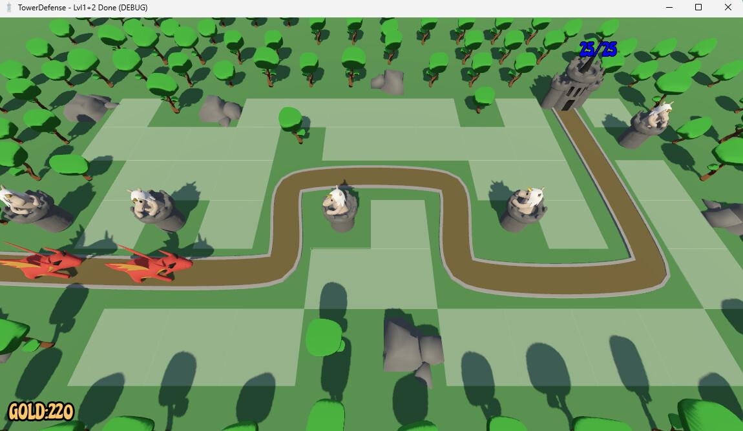
- Graphics Style: Fully 3D environments and character models rendered through an isometric camera perspective (topdown).

Figure 3. 3D Top Down View

The figure above shows the main inspiration for the visual style of our game. As seen in the image, we aim for a clean, simple 3D design that is easy to view from a top-down angle. This style will help players clearly see the difference between healthy natural areas and damaged, polluted zones.
- Modeling and Animation: All 3D assets, the localized animal forms, and the invasive chimeras, will be modeled, rigged, and animated entirely within Blender, and will also find free 3d assets online.
- Mobile Optimization: To maintain high frame rates on mobile devices, the 3D assets will utilize optimized, low-poly geometry.

Development Timeline Table

DEVELOPMENT TIMELINE
Phase | Tasks and Deliverables | May 2026 | June 2026 | July 2026 | August 2026 | September 2026
Phase 1 — Research and Pre-Production | Game concept finalization, ecological research, storyline development (GenoMorph worldbuilding, Dr. Sterling narrative) | ✔ | ✔
 | Animal biology research and transformation concepts | ✔ | ✔
 | UI sketches and interface planning |  | ✔
Phase 2 — Prototype Development | Player movement and controls system |  | ✔ | ✔
 | GenoMorph transformation (DNA switching system) |  | ✔ | ✔
 | Basic combat mechanics |  |  | ✔
Phase 3 — Core Gameplay Systems | Ecosystem restoration mechanics (environment healing system) |  |  | ✔ | ✔
 | Reflection and Defensive Mechanics |  |  | ✔ | ✔
 | DNA Knowledge Acquisition system (data collection & upgrades) |  |  |  | ✔
Phase 4 — Content Development | Level design (Wetlands, Rainforest, Reef, Mountains) |  |  |  | ✔ | ✔
 | Boss encounters (Chimera bosses development) |  |  |  | ✔ | ✔
 | Environmental effects (pollution, restoration visuals) |  |  |  |  | ✔
Phase 5 — Testing & Finalization | Gameplay testing and balancing |  |  |  |  | ✔
 | UI polishing, optimization, final build preparation |  |  |  |  | ✔
Phase 6 — Finalization and Presentation Preparation | Final gameplay polishing, bug fixing, and documentation completion |  |  |  |  | ✔
 | Final build preparation, optimization, and project presentation setup |  |  |  |  | ✔
Table 1. Development Timeline

The table above shows the complete development timeline of GenoMorph from May to September 2026, divided into six phases from planning to presentation. It begins with research and pre-production for the game concept, storyline, biology references, and UI design, followed by prototype development of movement, DNA transformation, and basic combat systems. Next is core gameplay development, including ecosystem restoration mechanics, survival features, and the DNA Knowledge Acquisition system. Content development covers biome creation, boss encounters, and environmental effects. Testing and finalization focus on balancing, bug fixing, UI polishing, and optimization, ending with final build preparation and documentation for presentation.

VI. Team Structure
The development of GenoMorph is managed by the developers called PhsynTaK’s, where each member is assigned specific responsibilities based on different areas of game development. The team structure ensures that the project’s gameplay systems, storyline, research, and overall presentation are organized efficiently while maintaining a unified creative direction.

Kent Dave R. Pilar – Lead Programmer and Technical Designer

Responsible for the technical development of the game. His role focuses on programming gameplay mechanics, implementing the top-down combat system, managing player movement and transformation mechanics, and integrating the GenoMorph’s DNA-switching functions. He also oversees technical optimization, game logic, user interface functionality, and overall system performance to ensure smooth gameplay on mobile devices.

Pshych Earl B. Caleñada – Narrative and Gameplay Designer

Assigned to the game’s storyline, worldbuilding, and gameplay structure. His responsibilities include designing the ecological themes, developing the progression of levels and boss encounters, creating educational gameplay mechanics, and organizing the quests, side missions, and biome concepts. He also ensures that the scientific and environmental lessons are properly integrated into the gameplay experience.

Thomas Kyle L. Galo – Researcher, Concept Developer, and Documentation Lead

Responsible for the research and documentation components of the project. His role includes gathering scientific and ecological references, organizing the game proposal, developing the innovation and differentiation concepts, and ensuring the educational content remains accurate and grounded in real-world biology and environmental science. He also assists in concept development, presentation design, and overall project coordination.

VII. References (APA 7th Edition)
Endling: Extinction is Forever. (n.d.). Steam. https://store.steampowered.com/app/898890/Endling__Extinction_is_Forever/
Godot Engine. (n.d.). Godot Engine – Free and open source 2D and 3D game engine. https://godotengine.org/
Ocean. (2026, May 21). Ocean. https://store.steampowered.com/category/ocean
Spore. (n.d.). Spore (PC). Steam. https://store.steampowered.com/app/17390/SPORE/
Studio Wildcard. (n.d.). ARK: Survival evolved. https://playark.com/
Universal Animation Library by Quaternius. (n.d.). itch.io. https://quaternius.itch.io/universal-animation-library

